FLOOD DETECTION USING SYNERGIC USE OF

OPTICAL AND SAR IMAGERY

**5TH SEMESTER PROJECT REPORT**

`

INDIAN INSTITUTE OF INFORMATION TECHNOLOGY, ALLAHABAD

Submitted to: Dr. Pooja Mishra Submitted by: IEC2016012<Nikhil Mundra>

IEC2016026<Agam Dwivedi>

IEC2016072<Ruchin Agrawal>

ACKNOWLEDGEMENT

We thank **Dr. Pooja Mishra** who provided insight and expertise that greatly assisted the project. Her suggestions have really helped in the creation of the project. We would also like to show our gratitude to **Ms. Nidhi Verma** (research scholar under Dr. Pooja Mishra) for guiding us during the course of this project.

# 

# Problem Statement

The research aims to provide flood inundation mapping by synergic use of Sentinel-1 (SAR) and Sentinel-2 (optical) satellite imagery.

# Optical vs SAR satellites

Optical satellites

* Very high resolution(VHR) (<1m)
* Are affected by **cloud coverage**.
* Acquired only during **day time**.
* Can’t detect **forested areas** due to passive sensor limitations.

SAR satellites

* Not affected by **cloud coverage**.
* Acquired during day and night time.
* Can also achieve a very high resolution**.**
* Very effective when the **standing water** creates a flat surface.
* Can’t detect in **urban and vegetated areas** due to resolution and active sensor limitations.

# Classification Algorithm

The proposed algorithm for the classification of the images is **Decision Tree**.

* It makes all possible alternatives and traces each alternative to its conclusion in a single view, allowing for easy comparison among the various alternatives.
* Nonlinear relationships between parameters do not affect tree performance  
  Non-linear relationship between variables will result in failing checks for simple regression models and thus make such models invalid. However, decision trees do not require any assumptions of linearity in the data. Thus, we can use them in scenarios where we *know* the parameters are nonlinearly related.

Decision Tree Algorithm with parameters

# SAR parameters

* + VV polarization.
* Optical parameters
  + Bands B1 - B12
    - B1 blue(440 - 510 nm)
    - B2 green(520 - 590 nm)
    - B3 red(630 - 685 nm)
    - B4 red edge(690 - 730 nm)
    - B5 near IR(760 - 850 nm)
  + Custom parameters
    - RSWIR (Red Short Wave Infrared)
      * RSWIR = (Red - SWIR) / (Red + SWIR)
      * SWIR = avg(B9, B10, B11)
      * SWIR range: 900 - 1700 nm
    - NDVI (Normalised Difference Vegetation Index)
      * NDVI quantifies vegetation by measuring difference between near-infrared ( which vegetation strongly reflects) and red light (which vegetation absorbs).
      * Range -1 to +1
      * NDVI = (NIR - Red) / (NIR + Red)
      * NIR = near infrared band (760 - 850 nm)

# Flowchart

Preprocessing

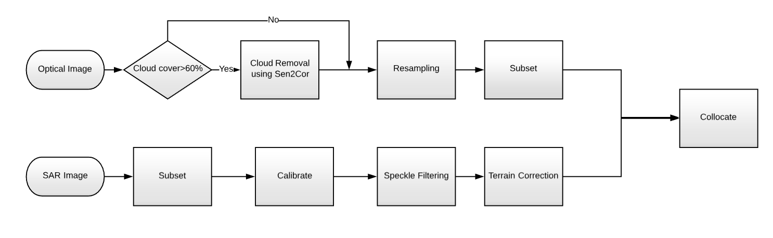

Training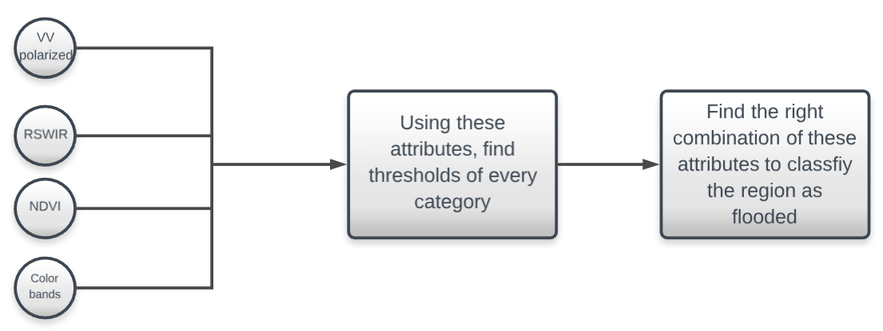

# Methodology

## Preprocessing steps for SAR image

1. Take the subset of the downloaded image by selecting on the **Menu** panel **Raster** > **Subset** . Specify parameters of the region of interest and click OK button. SNAP will open the product with all metadata relevant to the subset.

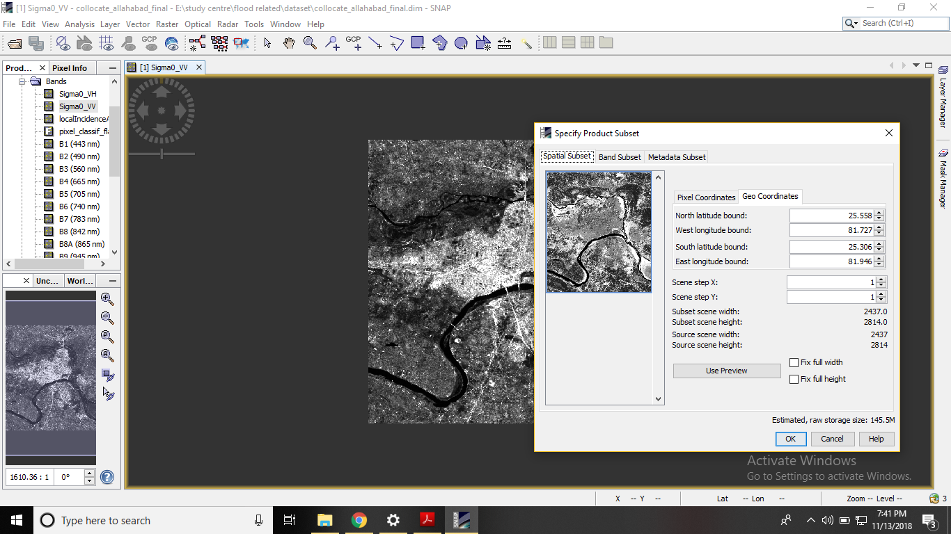

2. Calibration: Select on the Menu panel **Radar** > **Radiometric** > **Calibrate**.A Calibration window will open. Select the tab: **Processing Parameters**. This will create a new product with calibrated values of the backscatter coefficient.

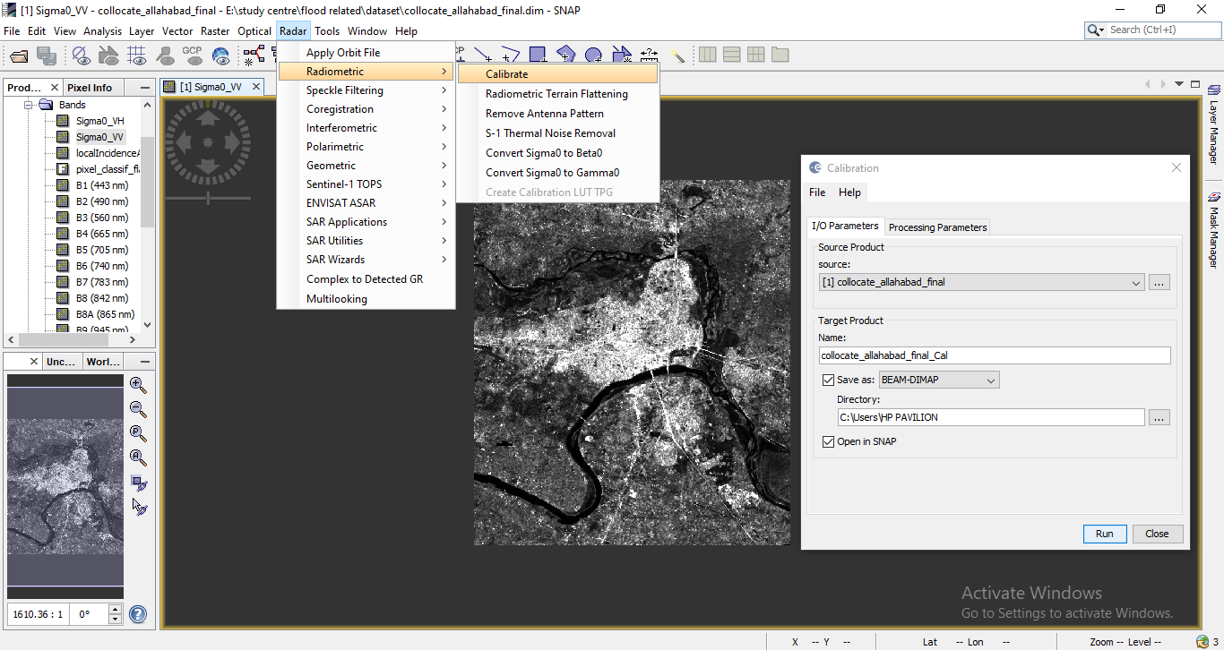

3. Filtration: Select **Radar** >**Speckle Filtering** > **Single Product Speckle Filter**. Select Processing Parameters sigma0_VV and **Lee filter** with window size **5 by 5**.

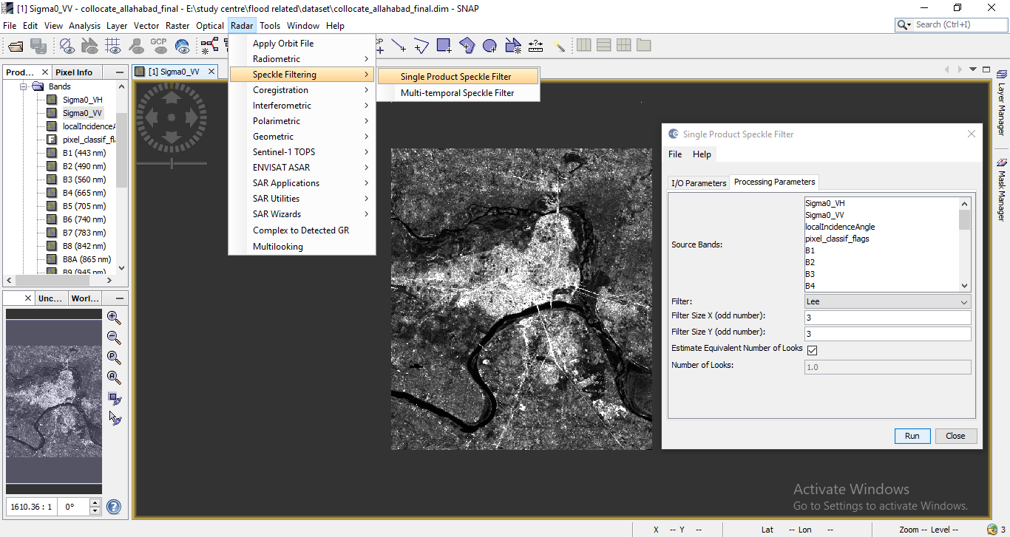

4. Terrain correction: Select **Radar** > **Geometric** > **Terrain Correction** > **Range-Doppler Terrain Correction** and select the processing parameters.

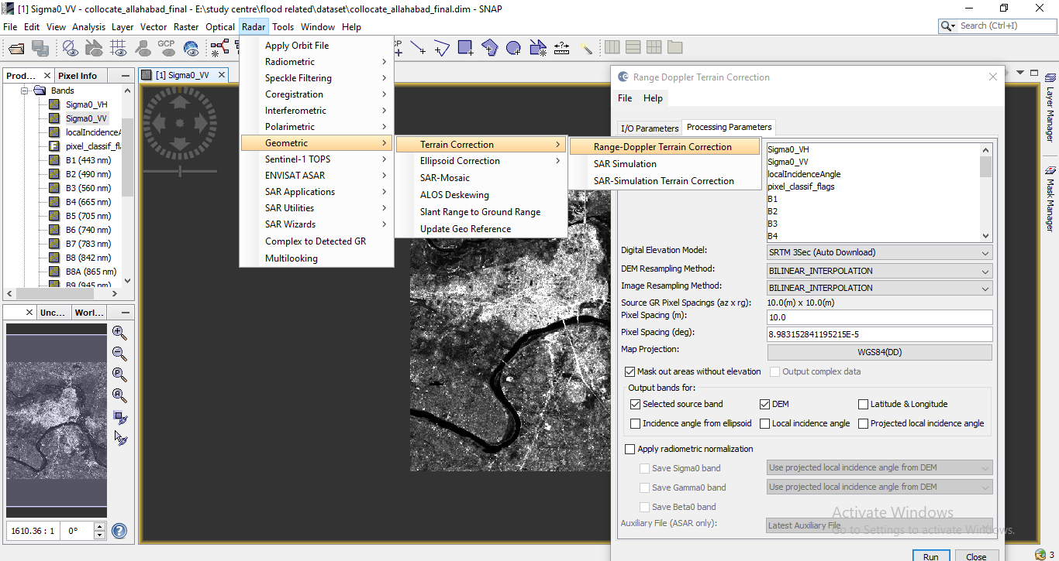

## 

## Preprocessing steps for optical image

1. Resampling: Select **Raster** > **Geometric operations** > **Resampling**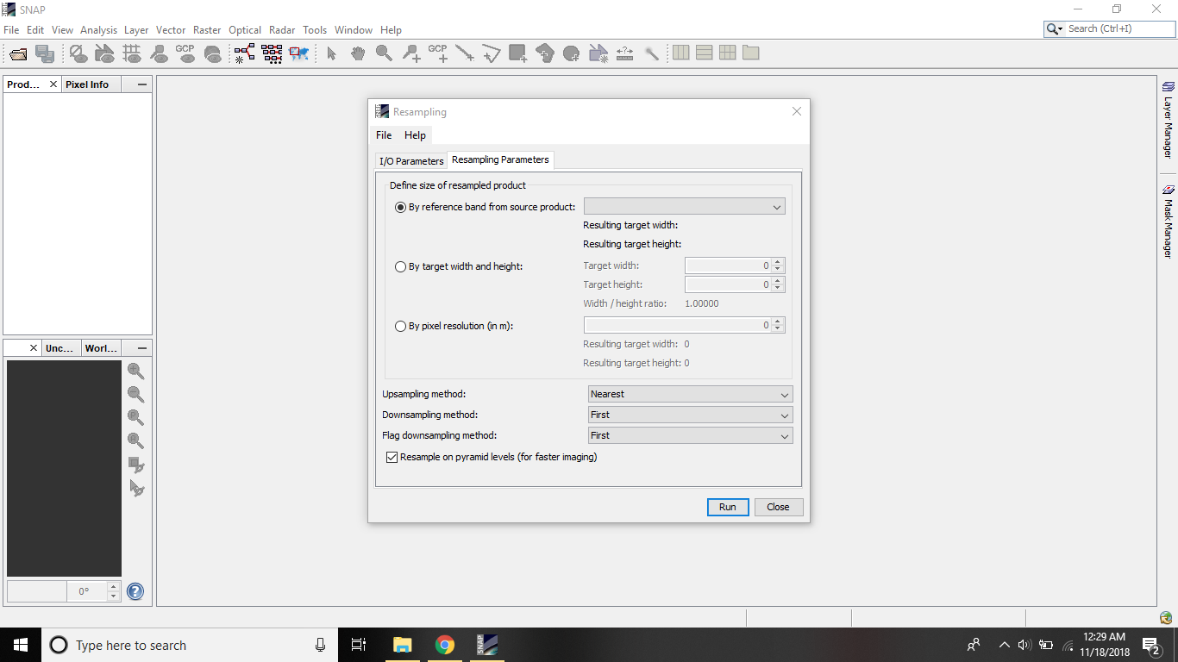
2. Take the subset of the image by selecting on the **Menu** panel **Raster** > **Subset** . Specify parameters of the region of interest and click OK button. SNAP will open the product with all metadata relevant to the subset.



Collocate SAR and Optical image:

1. After these preprocessing steps, collocate the SAR and optical image to make both the images of same resolution and to make the image of same geo-coordinates using **Raster > Geometric > Collocate .** 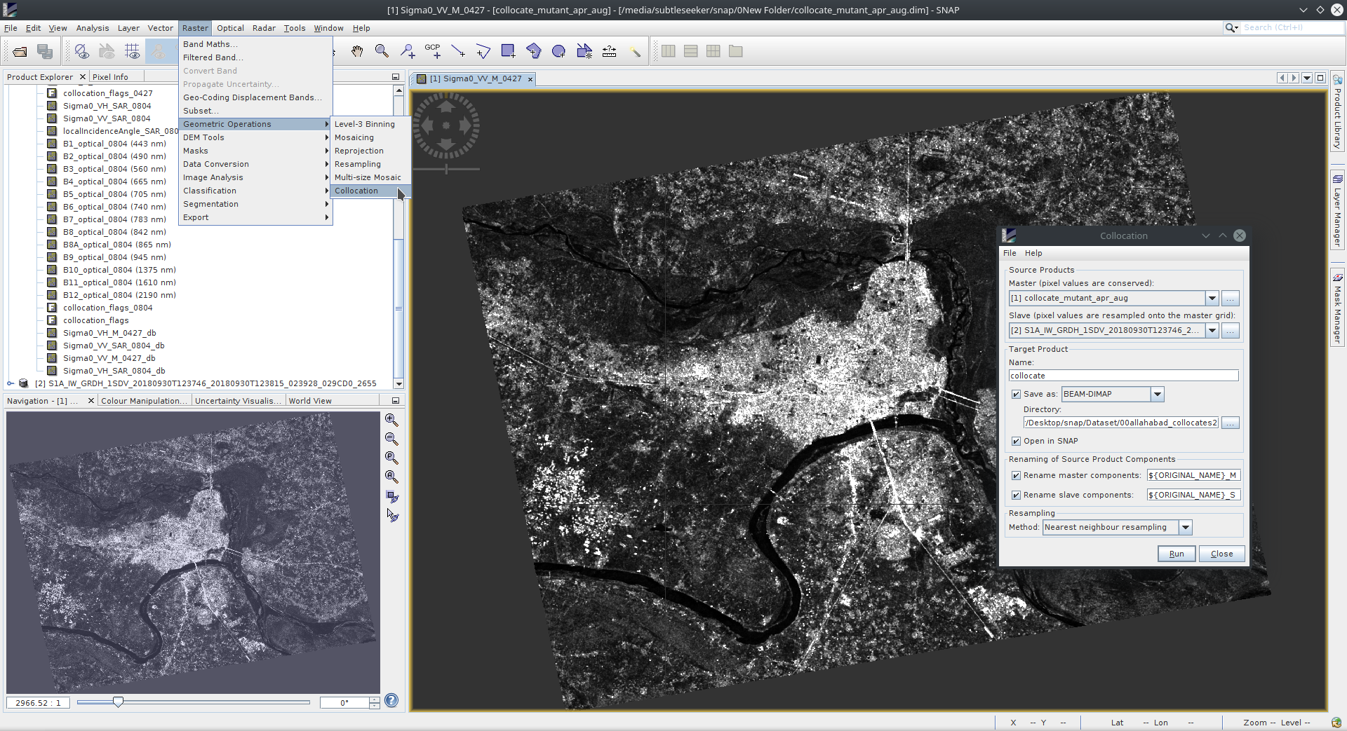

## Processing

## Analyzing the threshold of Sigma VV band to create a water mask by the histogram analysis and bandmath.

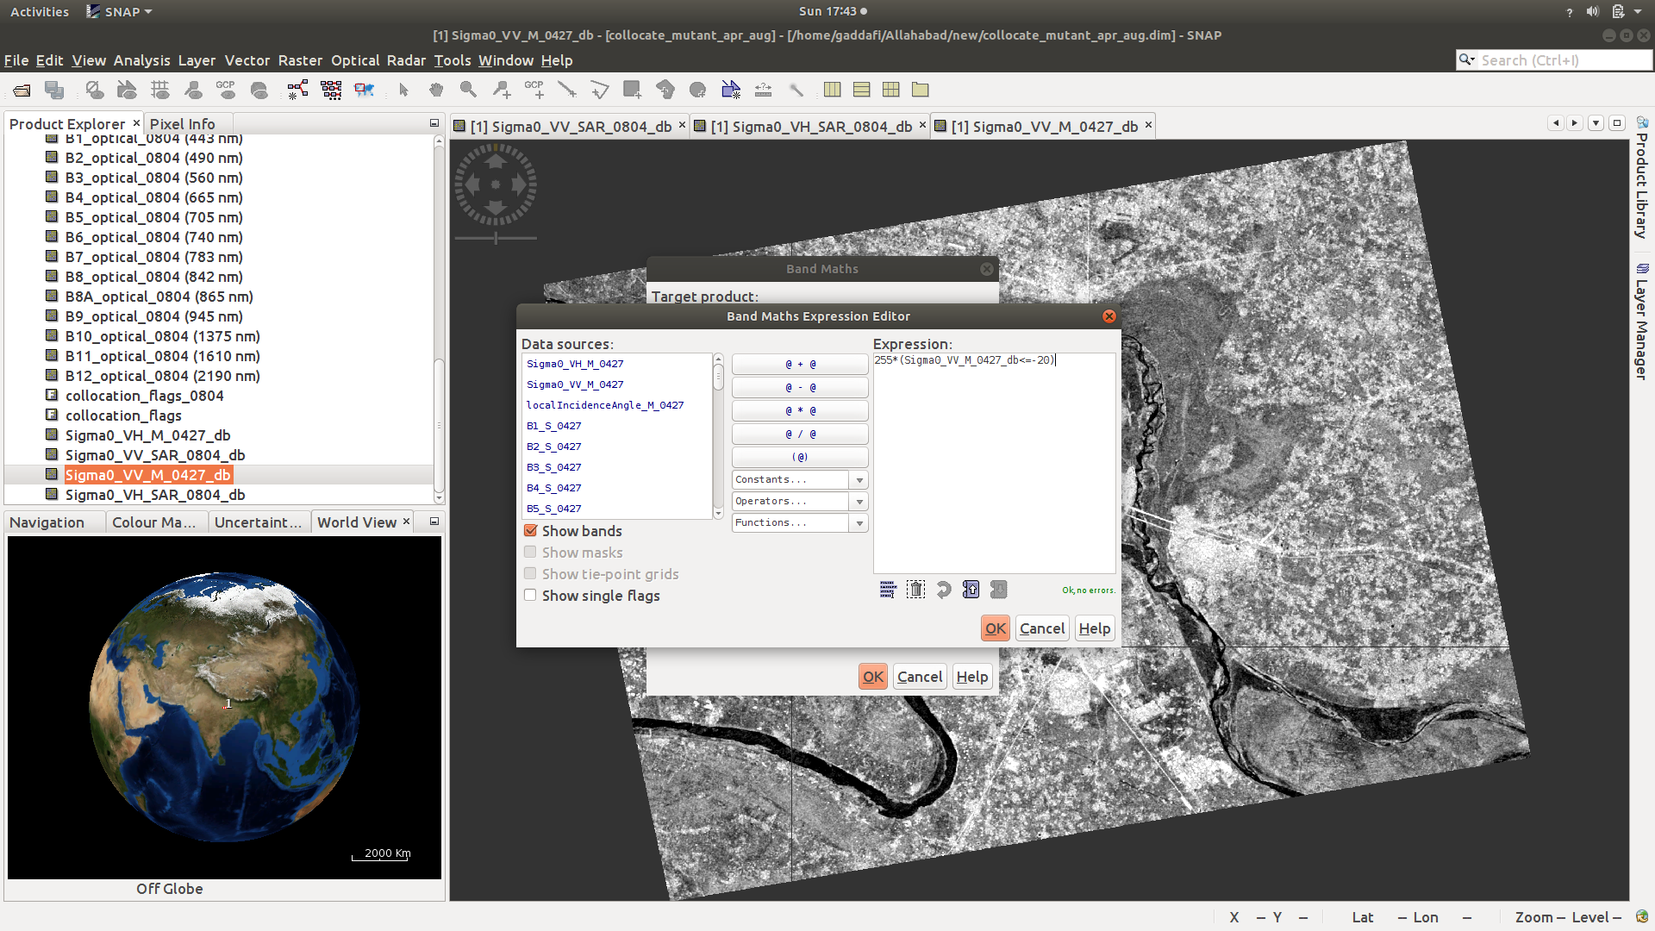

2. Conversion of bands into their ascii value with the help of ENVI.

3. Create bands of NDVI and RSWIR using band maths in ENVI.

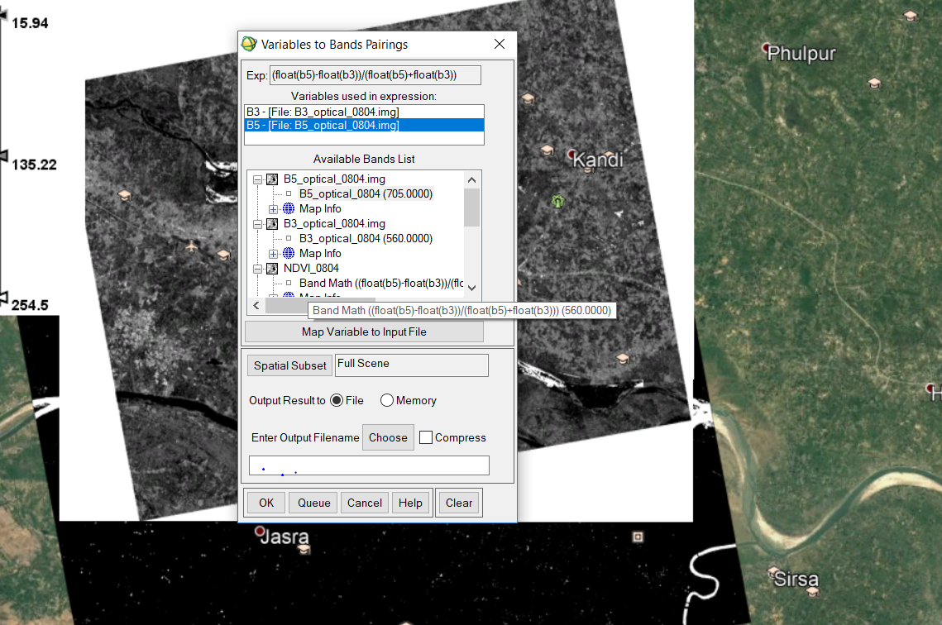

Training and testing

1. Now, programatically, select one image for training and another image for testing.
2. Train the classifier with the decision tree algorithm.
3. Test on both of the datasets for both April-dataset and August-dataset.
4. Subtract the tested flooded image with a non-flooded image to remove permanent water bodies.
5. Now overlay the resulted image on the google earth for the end user to see.

# Software/data requirements

* The raw data for SAR and optical images of *Sentinel 1, Ground Range Detected (GRD),* and different polarizations is obtained from <https://scihub.copernicus.eu>
* Processing of the images including *calibration, noise and speckle reduction, cloud removal, pixel-based mathematical operations and masking* is done by **Sentinel Application Platform (SNAP).**
* Data conversion and Band Maths creation of different attributes was done using **Exelis Envi.**
* Training and testing of the flooded image is done on **jupyter notebook** using **python.**

# Results

Accuracy achieved using decision tree = 99.65%

Average precision-recall score = 0.96

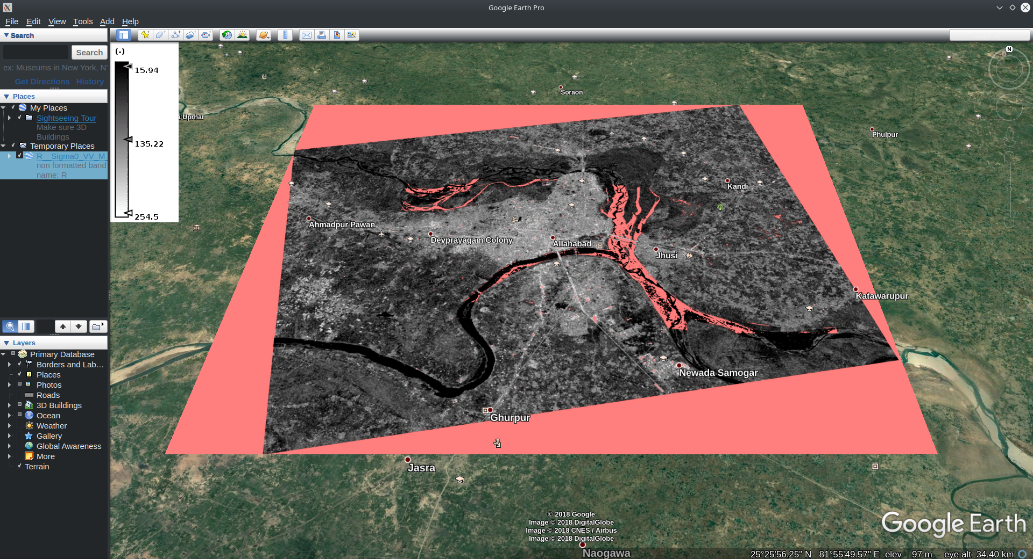

Confusion-matrix:



Average precision-recall:

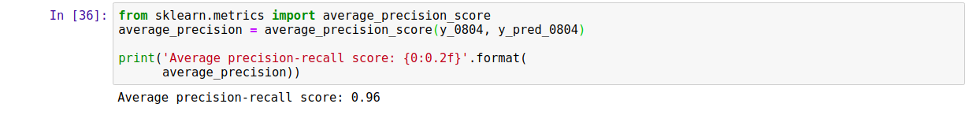

Accuracy:



# Conclusion

The proposed method aims at providing end users and decision makers with a new supervised tool for rapid flood mapping to support the first response to this kind of events.

Earlier standard for performing flood detection was using Optical Images which had many disadvantages like cloud cover, data available only for day-time. Our research performed this with SAR imagery which is an improvement over these limitations i.e. absolutely no cloud cover and availability of 24 hours data.

During scarce SAR dataset, our model could help predict similar results with optical images only.

Accuracy obtained by other algorithms using RFP-L2 method (Rapid flood processor) were k-mean—73%, SVM—73.4%,NN—76.6%, band ratio—75.0%, and difference image thresholding—66.1% <“Unsupervised Rapid Flood Mapping Using Sentinel-1 GRD SAR Images Donato Amitrano , Gerardo Di Martino , Senior Member, IEEE, Antonio Iodice , Senior Member, IEEE, Daniele Riccio, Fellow, IEEE, and Giuseppe Ruello, Member, IEEE”>.

Our algorithm achieved an accuracy of 99.56% with 2.6k pixels labelled as flooded from a total of 4.5M points.

# 

# Future prospects

1. **Make time-based flood prediction:** With a series of images, flood prediction could be made by analyzing the patterns of suitable attributes. This would require a high level of processing power and a much greater dataset.
2. **Make GUI based alerts:** GUI based alarm system could alert the people where the flood detected regions are found. Further the functionality could be increased by predicting the floods in a region and alerting government and environmentalists about the flood activities.

# FAQ

1. Why is RSWIR a better attribute than GSWIR (Green Short Wave Infrared) and NDWI(Normalized Difference Water Index)?  
    “The comparative analysis of NDWI, RSWIR and GSWIR using spatial statistical techniques and visual interpretation suggests RSWIR to be more efficient for delineating water bodies during floods.”[1]

# References

[1] Flood monitoring and damage assessment using water indices: A case study of Pakistan flood-2012, Akhtar Ali Memon, Sher Muhammad, Said Rahman,, Mateeul Haq

[2] An approach for flood monitoring by the combined use of Landsat 8 optical imagery and COSMO-SkyMed radar imagery Xiaohua Tong a, ⇑ , Xin Luo a , Shuguang Liu b , Huan Xie a , Wei Chao a , Shuang Liu a , Shijie Liu a , A.N. Makhinov c , A.F. Makhinova c , Yuying Jiang a

[3] Multi-temporal synthetic aperture radar flood mapping using change detection M.A. Clement 1 , C.G. Kilsby 1,2 and P. Moore

# Comments: